**Project**

**­**

***Title***

**Photocatalytic Degradation of Congo Red Dye from Aqueous Solution in Presence of Titanium Dioxide Photocatalyst**

**Submitted To-**

**Tania Islam**

**Assistant Professor**

**Computer Science & Engineering**

**University of Barishal**

**Submitted By-**

**Name: Ajhara Ghosh**

**Roll: 25**

**Batch: 49**

**ABSTRACT**

The textile industries produce large volume of wastewater and contain chemical associated with the dyeing process. A variety of physical, chemical, and biological methods, such as coagulation, adsorption, membrane filtration process, and oxidation-ozonation are presently available for treatment of dye from wastewater. The conventional processes are insufficient to purify the wastewaters. They transferred the compounds from aqueous to another phase, thus causing secondary pollution problem. Photocatalytic degradation by using TiO2 as catalyst is proven efficient to degrade the dye. Photocatalytic degradation is cost effective and capable of degrading any complex organic chemicals when compared to other purification techniques. TiO2 is an important photocatalyst due to its strong oxidizing power, non-toxicity and long term photostability. The TiO2 catalyst can transform organic pollutants into biodegradable compounds of low molecular weight. This study was designed to evaluate the effectiveness of degradation toward Congo red (CR) dye using TiO2 as a by varying catalyst dose, concentration of dye and light sources. The photocatalytic activities were monitored with a UV-visible spectrophotometer. Photodegradation of CR has been carried out by varying the catalyst dosage from 0.3 g to 1.5g. The degradation efficiency of CR is found to increase as the amount of the catalyst dosage increases up to a maximum value of 1.2 g. The degradation efficiency was inversely proportional with the initial concentration of CR. Almost 84% of CR molecules were found to be adsorbed at 60 minutes of irradiation under sunlight keeping the concentration 1×10-5 M with 1.2g of TiO2. The better efficiency under sunlight irradiation might be related with the mechanism of photocatalysis and intensity of the light.

**Keywords:** Congo red, photocatalyst, photodegradation, TiO2, wastewater.

|  |  |  |
| --- | --- | --- |
|  | **CONTENTS** |  |
| **SL No** | **Title** | **Page No** |
|  | **Chapter 1: Introduction** |  |
| 1.1 | Concept and scope of environmental chemistry | 8 |
| 1.2 | Pollution | 8 |
| 1.2.1 | Different types of pollution | 8 |
| 1.2.2 | Water pollution | 8 |
| 1.2.3 | Water pollutants and their composition | 9 |
| 1.2.4 | Water pollutants | 10 |
| 1.3 | Water pollution and the ecosystem | 11 |
| 1.4 | Waste water treatment | 12 |
| 1.4.1 | Method of wastewater treatment | 13 |
| 1.5 | Dye | 13 |
| 1.5.1 | Classification of dyes | 14 |
| 1.5.2 | Application of dye | 16 |
| 1.6 | Congo Red | 16 |
| 1.6.1 | Structure of Congo Red | 17 |
| 1.6.2 | Properties of Congo Red | 17 |
| 1.6.3 | Uses of Congo Red | 18 |
| 1.6.4 | Adverse effect of CR | 18 |
| 1.7 | Removal techniques of dyes | 18 |
| 1.7.1 | Physical method | 19 |
| 1.7.2 | Chemical method | 19 |
| 1.7.3 | Biological method | 19 |
| 1.8 | Photodegradation | 19 |
| 1.8.1 | Laws of photodegradation | 20 |
| 1.8.2 | Advantages of photodegradation over other methods | 21 |
| 1.8.3 | Factors affecting the photodegradation | 22 |
| 1.9 | Photocatalysts | 23 |
| 1.9.1 | TiO2 as a dye treatment photocatalyst | 23 |
| 1.9.2 | Advantages of TiO2 over other photocatalyst | 23 |
|  | **Chapter 2: Review of Literature** | **26** |
|  | **Chapter 3 :Methodology** |  |
| 3.1 | Materials | 32 |
| 3.1.1 | Methods | 32 |
| 3.2. | Preparation of stock solution of CR | 33 |
| 3.2.1 | Set up of calibration curve | 33 |
| 3.2.2 | Study the effect of the amount of TiO2 toward rate of degradation | 33 |
| 3.2.3 | Study the effect of concentration variation of dye toward the rate of degradation | 34 |
| 3.2.4 | Study the effect of rate of degradation in the sunlight and absence of light | 35 |
| 3.2.5 | **Chapter 4: Results** | 36 |
|  | Typical UV-visible spectra of Congo Red |  |
| 4.1 | Construction of calibration curve & determination of molar absorption coefficient (*Ԑmax*) of Congo Red | 38 |
| 4.2 | Effect of catalyst dose | 38 |
| 4.3 | Effect of dye concentration | 40 |
| 4.4 | Effect of light on the % of degradation | 40 |
| 4.5 | **Chapter 5: Discussion** | 41 |
|  | Effect of catalyst dose |  |
| 5.1 | Effect of initial concentration of dye | 43 |
| 5.2 | Effect of light on the % of degradation | 43 |
| 5.3 | IR spectra of Congo red | 44 |
| 5.4 | **Chapter 6: Conclusion**  **Chapter 7: References** | 46 |
|  |  |  |

|  |  |  |
| --- | --- | --- |
|  | **LIST OF TABLES** |  |
| **Table No** | **Title** | **Page No** |
| 4.1 | Measured absorbance of Congo Red at wavelength 498 nm | 39 |
| 4.2 | % of Degradation after 60 minutes with different amount of TiO2 under UV-light at 498 nm | 40 |
| 4.3 | Absorbance and percentage of degradation at different concentration variation with 1.2g of TiO2. | 40 |
| 4.4 | % of degradation of CR at UV-light, Sun-light and in the absence of light at different time interval | 41 |

|  |  |  |
| --- | --- | --- |
|  | **LIST OF FIGURES** |  |
| **Figure No** | **Title** | **Page No** |
| 1.1 | Mindless dumping of industrial waste and garbage in Buriganga | 9 |
| 1.2 | Waste water treatment process | 12 |
| 1.3 | Different colour dyes available in markets | 14 |
| 1.4 | Factors affecting the photodegradation | 22 |
| 3.1 | Several concentration of dye solution | 33 |
| 3.2 | Photodegradation under UV light. | 34 |
| 3.3 | UV-Visible spectrophotometer. | 35 |
| 3.4 | Sample collection in test tube. | 35 |
| 3.5 | Photodegradation under sunlight | 36 |
| 4.1 | UV-visible spectrum of Congo red (decreasing concentration from top to bottom) | 38 |
| 4.2 | Calibration curve of Congo red at 498nm | 39 |
| 4.3 | Images of the continuous decolorization (left to right → 10 to 60 minutes of reaction time) under sunlight, UV light and in dark respectively | 41 |
| 5.1 | % of photodegradation with various amounts of TiO2 at 498nm | 43 |
| 5.2 | % of photodegradation at different concentration of Congo red with 1.2g of TiO2 | 44 |
| 5.3 | % of degradation of CR under sunlight, UV light and in absence of light with 1.2g of TiO2 respectively | 45 |
| 5.4 | IR analysis of pure Congo red and degraded Congo red. | 46 |

**CHAPTER 1**

**INTRODUCTION**

* 1. **Concept and Scope of Environmental Chemistry**

Environmental Chemistry is the discipline which deals with:

1. the environmental impact of pollutants
2. the reduction of contamination and
3. the management of the environment.

Environmental Chemistry is thus the study of the behavior of pollutants with respect to their environmental fate and effects on the environment. In broader terms, it is the study of the source, reactions, transport, effect, and fate of chemical species in the air, water and soil and the effect of human activity upon these [4].

* 1. **Pollution**

Pollution is the introduction of contaminants into the natural environment that causes adverse change. Pollution can take the form of any substance or energy. Pollutants, the components of pollution, can be either foreign substances/energies or naturally occurring contaminants.

* + 1. **Different Types of Pollution**

|  |  |
| --- | --- |
| * Water Pollution. * Air Pollution. * Soil Pollution. * Thermal Pollution. | * Radioactive Pollution. * Noise Pollution. * Light Pollution |

**1.2.2 Water Pollution**

Water pollution is a state of deviation from the pure state, whereby its normal function and properties are affected [5]. In recent years, environment pollution had become crucial especially in water pollution. The pollutions of water are mainly caused by large amounts of dyes which are produced from textile, cosmetics, paper, leather, food and other industries. Textile industries are one of the most common industries that consume a lot of water in their processing textile. Wastewater generated by textile industries contains the considerable amount of non-fixed dyes especially azo dyes. It is estimated that 60% of dyes used rising great environmental concern especially in water [6] According to [7], the release of dyes into the environment caused serious problems due to their toxic, mutagenic and carcinogenic characteristic of the dye.

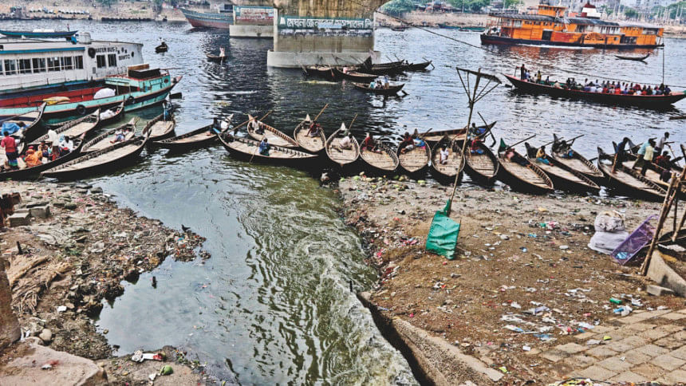

**Figure 1.1:** Mindless dumping of industrial waste and garbage in Buriganga.

* + 1. **Water Pollutants and Their Composition**

The textile wastewater containing pollutants that been characterized as a low biodegradability compound and high in organic content [8]. Due to the organic pollutant toxicity, it takes a long period for microorganisms to degrade those compounds [9]. The potential of toxicity of certain dye in receiving water has been a considerable matter in last two decades [10]. The presence of an even small number of dyes is clearly visible and will influence water environment. Dyes can be defined as the different type of color particle which consist of a complex unsaturated aromatic compound that has high volume in organic content, salt content and low in biodegradation. It can differ in term of their chemical composition. Congo red dye is commonly used in textile industry as an anionic dye as it has the complex structure with various di azo aromatic groups.

AZ dyes are considered as a major group of dyes produced worldwide due to the ease in its synthesis [11]. The azo compound contains at least one azo group (-N=N-). The highly substituted aromatic rings that combining with one or more azo group will characterize their chemical structure. According to [12], azo dyes are designed to endure toward sun irradiation, chemicals, water and microorganisms. The substituted ring structure makes the molecule recalcitrant and causing the conventional wastewater treatment processes does not degradable [8]. When being released into the environment, these dyes will damage the living organism by stopping the re-oxygenation capacity of water and blocking sunlight. If the color of dyes does not remove properly, the photosynthesis processes of aquatic life are affected due to low of ultraviolet light penetration [8].

* + 1. **Water Pollutants**

Water pollutants are those materials that are the responsible for the water pollution. The large number of water pollutants may be broadly classified under the following types [13].

1. **Inorganic Pollutants**

This group consists of inorganic salts, mineral acids, finely-divided metals or metal compounds, trace elements, complexes of metals with organic in natural water, and organometallic compounds. Polyphosphate in detergent, the major source of phosphate in water, serves as algal nutrients and is of much concern as water pollutants [14].

1. **Organic pollutants**

There are many different types of organic pollutants, such as Hydrocarbons, PAH (polyaromatic hydrocarbon) PCB (polychlorobenzene) etc. Aromatic hydrocarbons such as PAHs are much more reactive than any kinds of hydrocarbons. PCBs are stable and unreactive fluids that are used as hydraulic fluids, coolant insulation fluids in transformers and plasticizers in paints. There are many different PCB's. None of them are water-soluble. In many countries PCBs are restricted. Insecticides such as DDTs are very dangerous because they accumulate in fat tissues of lower animals and then enter the food chain. They have been restricted for decades [15].

**C. Radioactive materials**

Nuclear weapons testing in air, leakage from underground nuclear denotations etc. give rise to radioactive fallout have far reaching effects on the environment and mankind.

**D. Thermal pollution**

Coal fired power plant are associated with the problem of thermal pollution by cooling the condenser coils of it with water from nearby river or lake. It decreases D.O. of water and affects the aquatic life [16].

**E. Sediments**

The natural process of soil erosion gives rise to sediments in water. It represents the most extensive pollutants of surface water. Bottom sediments are important sources of inorganic and organic matter.

**1.3 Water Pollution and the Ecosystem**

Water pollution disrupts ecosystems by harming organisms, altering food chains, and causing biodiversity loss. Water pollution is a significant threat to the balance of ecosystems. It can have a profound impact on the health and survival of various organisms, including plants, animals, and microorganisms. When pollutants enter a water body, they can directly harm aquatic life by causing diseases or even death. For instance, heavy metals like lead and mercury can accumulate in the bodies of fish, leading to health problems and reduced populations. This not only affects the fish species but also the predators that rely on them for food. Moreover, water pollution can alter the food chains within an ecosystem. Pollutants can kill off certain species, creating a ripple effect throughout the food chain. For example, if a pollutant kills off a large number of algae, it can lead to a shortage of food for herbivorous aquatic animals. This, in turn, can affect the carnivorous species that feed on the herbivores, leading to an overall imbalance in the ecosystem.

In addition, water pollution can lead to a loss of biodiversity. Biodiversity is crucial for the health of an ecosystem as it ensures stability, resilience, and productivity. However, when pollutants contaminate water bodies, they can create an inhospitable environment for many species, leading to a decrease in biodiversity. For instance, oil spills can smother marine life, leading to a significant reduction in the number of species in the affected area. In conclusion, water pollution poses a significant threat to the balance of ecosystems. It can harm organisms, disrupt food chains, and lead to a loss of biodiversity, all of which can have far-reaching impacts on the health and stability of the ecosystem. Therefore, it is crucial to take steps to prevent and mitigate water pollution to protect our ecosystems.

**1.4 Waste Water Treatment**

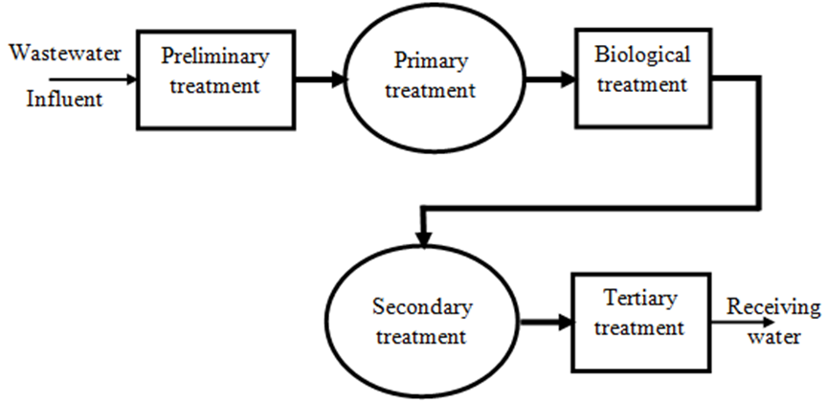

**Figure 1.2:** Waste water treatment process

Wastewater treatment is the process of improving the quality of wastewater and converting it into an effluent that can be either returned to the nature or incorporated to the water cycle with minimum environmental issues or that can be reused.

**1.4.1 Method of Wastewater Treatment**

There are different techniques for the treatment of industrial wastewater [17].

|  |  |
| --- | --- |
| 1. **Removal of dissolved solids**  * Ion exchange * Electro dialysis * Ion exchange * Electro dialysis | **C. Removal of dissolved organic compounds**   * Sludge treatment * Disinfection * Adsorption |
| **B. Removal of suspended solids**   * Coagulation and Flocculation * Filtration | **D. Phosphate removal**   * Chemical treatment * Biological treatment |

* 1. **Dye**

Dyes are substances those are used to color various materials, including [**textiles**](https://textileengineering.net/what-is-textile-engineering/), plastics, paper, and other materials. They are soluble, coloured organic compounds that are usually applied to textiles from a solution in water. Dyes can be natural or synthetic. They are designed to bond strongly to the polymer molecules that make up the [**textile fibre**](https://textileengineering.net/classification-of-textile-fibres/). A dye is used to impart color to materials of which it becomes an integral part. Dyes are widely used in many industries, including textiles, printing, and cosmetics, to add color to products and materials. Some common types of dyes include acid dyes, basic dyes, disperse dyes, reactive dyes, and vat dyes, each with its own specific properties and uses.

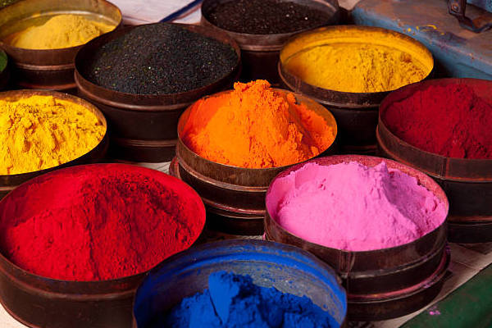

**Figure 1.3:** Different color dyes available in the market.

* + 1. **Classification of Dyes**

Dyes can be classified into various categories based on their origin, chemical structure, solubility, application method, and other factors. Some common classification of dyes include:

**1. Classification of Dyes Based on Origin:**

* Natural dyes
* [Synthetic dyes](https://textileengineering.net/synthetic-dyes-properties-types-application/)

**2. Dyes Classification Based on Chemical Structure:**

* Azo dyes
* Anthraquinone dyes
* Triphenylmethane dyes
* Phthalocyanine dyes
* Quinoline dyes
* Nitroso dyes
* Indigoid dyes
* Natural dyes

**3. Classification of Dyes Based on Application Method:**

* Direct dyes
* Reactive dyes
* Acid dyes
* Basic dyes
* Disperse dyes
* Vat dyes
* Pigments

**4. Dyes Classification Based on Solubility:**

* Water-soluble dyes
* Oil-soluble dyes
* Solvent dyes

**5. Classification of Dyes Based on Use:**

* Textile dyes
* Food dyes
* Ink dyes
* Leather dyes
* Hair dyes
* Medical dyes

**1.5.2 Application of dye**

* Acid dye : Man-made fiber (Nylon)

: Natural fiber (Silk, Wool)

* Basic (Cationic) dye : Jute, Acrylic
* Direct (Substantive) dye : Man-made fiber (Viscose)

: Natural fiber (Cotton)

* Vat dye : Man-made fiber (Viscose)

: Natural fiber (Cotton, Silk, Wool)

* Azoic dye : Cotton, Viscose
* Mordant dye : Cotton, Wool, Silk
* Sulfur dye : Cotton, Viscose
* Disperse dye : Nylon, Polyester, Acrylic, Tri-acetate and Di-acetate
* Reactive dye : Cotton, Wool, Silk, Viscose, Nylon
* Onium dye : Cotton, Jute
* Pigment : Cotton, Man-made fiber
* Mineral : Cotton, Wool, Silk
* Aniline Black : Cotton
* Rapid and Rapidson dye : Cotton
  1. **Congo Red**

**Congo red** is an [organic compound](https://en.m.wikipedia.org/wiki/Organic_compound), the sodium salt of 3,3′-([1,1′-biphenyl]-4,4′-diyl)bis(4-aminonaphthalene-1-sulfonic acid). It is an [azo dye](https://en.m.wikipedia.org/wiki/Azo_dye). Congo red is water-soluble, yielding a red [colloidal](https://en.m.wikipedia.org/wiki/Colloid) solution; its solubility is greater in organic solvents. The use of Congo red in the textile industry has long been abandoned, primarily because of its carcinogenic properties but it is still used for [histological staining](https://en.m.wikipedia.org/wiki/Staining_(biology)).

* + 1. **Structure of Congo Red**

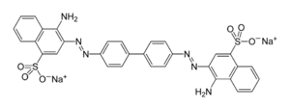

* + 1. **Properties of Congo Red**
* Molar mass : 696.665
* Formula : C32H22N6Na2O6S2
* Appearance : Powder, Red
* Melting point : > 360 0 C
* Solubility : Water
* Hydrogen bond donar count : 2
* Hydrogen bond acceptor count : 12
* Rotatable bond count : 5
* Heavy atom count : 48
* Covalently bond atom count : 3
* Formal charge : o
  + 1. **Uses of Congo Red**
* As a colorant in industries such as textile, printing, dyeing, and rubber.
* Additionally, Congo red dye is used as a model in experimental studies for the treatment of textile wastewater.
  + 1. **Adverse Effect of CR**

CR adversely affects the human body leading to various diseases, which can be fatal, when its concentration is high from being cytotoxic (genotoxic, hemotoxic, and neurotoxic), carcinogenic, and mutagenic [18]. Among the organs, it affects the eyes, skin, respiratory, and reproductive systems. Benzidine (its toxic metabolite) causes an allergic reaction and is a carcinogenic product. Benzidine is a bladder carcinogen and binds covalently to cellular macromolecules leading to activity inhibition. In animal experiments, benzidine-based dyes produce hepatocarcinoma, splenic sarcoma, nuclear abnormalities, and chromosomal errors in mammalian cells [19]. CR can cause platelet aggregation, thrombocytopenia, and disseminated micro-embolism by lowering blood protein content [20].

* 1. **Removal Techniques of Dyes**

According to a recent report [19-21] annual production of textile dyes is 7x104 tons. About 60% of all dyes used by the textile industry are reactive dyes azo dyes in particular, constitute an almost 80% of the reactive dyes. Most of the azo dyes are not biodegradable by aerobic treatment processes, but they can be decolorized by anaerobic treatment. As results cleavage of the nitrogen double bond occurs, and the resulting fragments, which are aromatic amines, are proven carcinogens. Reactive dyes are environmentally hazardous because of the toxicity. The toxicity of these wastes can be reduced significantly by using an aerobic treatment, which converts these aromatic amines into less harmful products.

**1.7.1 Physical Method**

* Adsorption
* Reverse osmosis
* Ultrafiltration

**1.7.2 Chemical Method**

* Chlorination
* Ozonation [21]
* Adsorption on organic or inorganic matrices
* Precipitation
* Photodegradation with photocatalyst
* Advanced oxidation processes such as Fenton and Photo-Fenton catalytic reaction, H2O2/UV [22].

**1.7.3 Biological Method**

* Microbiological or enzymatic decomposition [23]
* Biodegradation

These conventional biological treatment processes are ineffective for synthetic dyes removal having recalcitrant nature. [24,25]

**1.8 Photodegradation**

Photocatalytic degradation is one types of degradation that can be used to degrade the dyes. This photo degradation process will change the structure of the hazardous dye into the substance that is more environmentally friendly by altering it molecule using photon found in UV, infrared and other. The usage of the catalyst such as titanium dioxide (TiO2) and zinc oxide (ZnO) in photo degradation process is considered as having the potential to degrade various environmental pollutants including the dye. Catalysts are the safer compound, which it did not undergo any physical or chemical changes within the process. Thus, this property had made catalyst become preferable in degradation of diazo dyes. There are two types of photocatalysis which is homogeneous and heterogeneous photocatalysis. This study is focusing on heterogeneous photocatalysis. This type of photocatalysis will practically including titanium dioxide as a semiconductor. In previous studies, heterogeneous photocatalytic degradation has been proven its efficiency to remove pollutant in wastewater [26].

* + 1. **Laws of Photodegradation:**

**1.** Grotthus Draper’s law is “The first law of photochemistry states that light must be absorbed for photochemistry to occur. This is a simple concept, but it is the basis for performing photochemical and photo biological experiments correctly. If light of a particular wavelength is not absorbed by a system, no photochemistry will occur and no photo biological effect will be observed”.

2. Stark-Einstein’s law is “The second law of photochemistry states that for each photon of light absorbed by a chemical system, only one molecule is activated for photochemical reaction. This law is true for ordinary light intensities, however, with high-powdered leasers, two-photon reactions can occur, i.e., the molecule is raised to a higher energy state than produced by single - photon absorption”.

3. The Beer-Lambert law states that the quantity of light absorbed by a substance dissolved in a fully transmitting solvent is directly proportional to the concentration of the substance and the path length of the light through the solution. This is the linear relationship between absorbance and concentration of an absorbing species. The Beer - Lambert law implies that both the type and concentration of the molecules are important in the process of radiation absorption. There is no information in this law about the nature of radiation. Also, this law does not consider the properties of the material nor the angle of the incident beam which together determines the actual amount of beam energy being used (absorbed or reflected and transmitted), just to mention the most important factors causing nonlinearity of the results. The Beer-Lambert law is a concentration of the absorbing species, the extinction coefficient of the absorbing substance, etc.)

**1.8.2 Advantages of Photodegradation over Other Methods**

The textile industry is the largest consumer of dyes for various dyeing, printing. Azo dyes are considered as a major group of dyes produced worldwide due to the ease in its synthesis [27]. The azo compound contains at least one azo group (-N=N-). The highly substituted aromatic rings that combining with one or more azo group will characterize their chemical structure. According to [28], azo dyes are designed to endure toward sun irradiation, chemicals, water and microorganisms. The substituted ring structure makes the molecule recalcitrant and causing the conventional wastewater treatment processes does not degradable [29]. When being released into the environment, these dyes will damage the living organism by stopping the reoxygenation capacity of water and blocking sunlight. If the colour of dyes does not remove properly, the photosynthesis processes of aquatic life are affected due to low of ultraviolet light penetration [30]. In [31] reported that traditional wastewater treatment technologies were proven to be N. H. Harun et al. J Fundam Appl Sci. 2018, 10(1S), 832-846 834 noticeably less productive in the treatment of wastewater that containing synthetic dyes. In this study, the chemical methods are focused.

Waterborne chemical pollution entering rivers and streams cause tremendous amounts of destruction. Photochemical degradation of phenol derivatives represents an alternative method for biological 29 detoxification. Photo-degradation in the presence of suspended semiconductor particles may be either by a ‘direct’ process, by organic molecules adsorbed on the surface of the particles which interact with holes and hydroxyl radicals on the surface or they may be ‘indirect,’ by interaction of the organic molecules with hydroxyl radicals in the bulk of the solution.

* + 1. **Factors Affecting the Photodegradation**

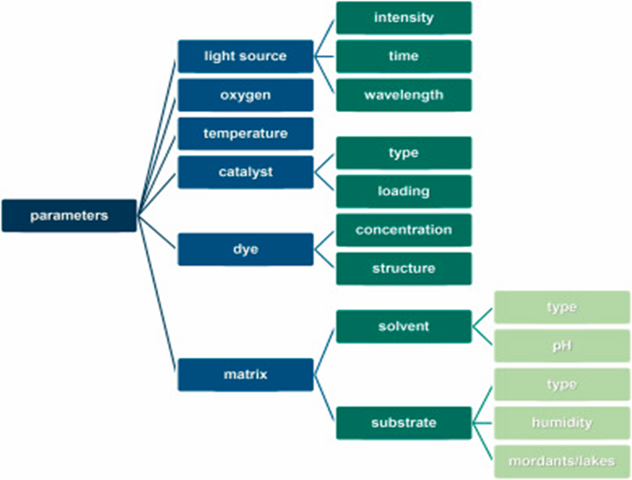

**Figure 1.4:** Factors affecting the photodegradation.

* 1. **Photocatalysts**

The term photocatalyst is a combination of two words: photo related to photon and catalyst, which is a substance altering the reaction rate in its presence. Therefore, photocatalysts are materials that change the rate of a chemical reaction on exposure to light. This phenomenon is known as photocatalysis.

1. *Homogeneous photocatalysis*: When both the semiconductor and reactant are in the same phase, i.e. gas, solid, or liquid, such photocatalytic reactions are termed as homogeneous photocatalysis.
2. H*eterogeneous photocatalysis*: When both the semiconductor and reactant are in different phases, such photocatalytic reactions are classified as heterogeneous photocatalysis.

**1.9.1 TiO2 as a Photocatalyst for the treatment of Dye**

UV radiation below 390 nm stimulates valence band electrons in semiconducting particles that are suspended in contaminated water. These electrons are promoted to the conduction band creating hole in the valence band. The holes in the semiconducting valence band can migrate to the surface and either can oxidize an adsorbed species directly or can react with water and adsorbed hydroxyl ion to produce **•**OH radicals that are powerful oxidizers capable of attacking dissolved organics. For both cases of oxidative pathways, the final products are reported to be water, carbon-dioxide and other simple and harmless inorganic products.

**1.9.2 Advantages of TiO2 over Other Photocatalyst**

This study focused on photocatalytic process by using TiO2 as the catalyst with two different treatments used during this process which is under solar light and under UV lamp. The semiconductor catalyst chosen in this study is titanium dioxide (TiO2) as it able to degrade the pollutant into the simplest compound without harming the environment. Besides, this semiconductor is affordable, easy to obtain and environmentally friendly as a catalyst for the photo-oxidation of organic compounds [32]. The main objective of this study was to evaluate the efficiency of degradation of Congo red dye by using TiO2 as a catalyst.

Among various types of photocatalysts, titanium dioxide (TiO2) assisted photocatalytic oxidation has received much attention the last few years due to its non-toxicity, strong oxidizing power and long-term photostability [15]. Titanium dioxide (TiO2) is a white powder semiconductor having a wide band gap of 3.0-3.2 eV [16-17]. It can be excited by UV light with a wavelength below 415 nm (in its rutile form). However, the use of TiO2 is limited as only about 3–4% of the solar spectrum falls within UV-range [19-22]. In general, there are three types of titanium dioxide i.e., anatase, rutile and brookite. In general, TiO2nanoparticles are widely available commercially or can be easily prepared using sol gel method. Typically, anatase phase is often found having particle size equal to 10 nm or less with a band gap of 3.2 eV corresponding to a UV wavelength of 385 nm [23]. Comparatively, though some exceptions exist, rutile phase generally exists having particle size in the order of 50 nm or so [24]. Moreover, rutile has a smaller band gap of 3.0 eV with excitation wavelengths extending to visible 410 nm range. Thermodynamics dictates that heating the anatase phase result in gradual phase transformation of anatase to rutile and therefore depending on the method of preparation mix phase anatase-rutile can be easily prepared or purchased. For example, some commercially available TiO2 that is a mixture of two phases, 80% anatase and 20% rutile and has usually a BET area of 50 mg/L has widely been studied [25]. Most of the studies have been carried out with anatase phase due to its high photocatalytic efficiency and adsorption affinity for the organic compounds as compared to the rutile phase [26, 27]. Shiga et al. [28] using nano 32 crystalline film electrodes of TiO2 for photo electrochemical activities showed that the anatase has a higher photoactivity than rutile phase at a longer wavelength. This is due to the fact that anatase phase due to its greater hole trapping ability (about 10-fold) exhibits lower recombination rates compared to rutile type [29,30]. Therefore, anatase is generally regarded as photochemically more active phase of TiO2 due to these combined effects. Moreover, recently developed various forms of TiO2, such as TiO2 powders, TiO2 film, supported TiO2 [31,32], TiO2 nanotubes [33] and doped TiO2 [34,35] have been evaluated through degradation of dyes and phenolic compounds. Such studies demonstrated the higher efficiency of various forms of TiO2 used for removal of dyes and phenolic compounds from aqueous solutions [36].

**Chapter 2**

**Review of Literature**

This chapter is a review of journals and references available in literature being pertinent to the research topic. Photodegradation of various classes of dyes has been a subject of extensive research and various findings have been reported in the literature. In order to assess the overall status of the problem under

**2.1** **Literature Review on Photocatalytic Degradation of Dyes**

**Nogueira et. al. (1993)** studied photodegradation of Methylene Blue (MB) under solar light using three catalysts i.e. metal oxides (TiO2, ZnO) and metal sulfides (CdS). It was found by the work that TiO2 was the best of the three catalysts.

**R. Goyal et. al. (2017)** investigated photocatalytic degradation of Rhodamine B using nanosized TiO2. In photocatalytic degradation the decomposition of Rhodamine B had been done using UV illumination. The absorbance of the reaction mixturewas measured at various time intervals using Spectrophotometer. Controlled experiments confirmed the necessity of light, semiconductor catalyst and oxygen to follow the photocatalytic path to proceed the photobleaching of dye. Effect of pH, amount of photocatalyst (TiO2) and initial dye concentration had been studied over photocatalytic degradation of Rhodamine B. A tentative mechanism had also been proposed.

**S. L. Jr. et. al. (2017)** demonstrated the photocatalytic degradation of Rhodamine B by cotton textile coated with SiO2-TiO2 and SiO2-TiO2-HYcomposites. The work was devoted to study the photocatalytic ability of cotton textiles functionalized with SiO2-TiO2 and SiO2-TiO2-HY composites to degrade a dye molecule. Coatings were prepared by sol-gel method and calcined at different temperatures in arrange of 400–750oC. FTIR confirmed the existence of SiO-Ti bounds and the band located in the region between 570 and 600 cm-1 was used to calculate the frame work Si/Al ratio of HY in the SiO2-TiO2-HY composites. XRD confirmed the presence of nanosized TiO2 (anatase phase) in all calcined composites. Nitrogen adsorption isotherms showed a decrease in surface area and pore volume for higher calcinations temperature. A simple mechanical process was used to impregnate the different composites on the cotton substrates. The photocatalytic activity of cotton textiles functionalized with SiO2-TiO2 and SiO2-TiO2-HY composites was tested via the degradation of Rhodamine B (RhB) under similar solar irradiation. The best catalytic performance was achieved with the SiO2-TiO2 and SiO2-TiO2-HY composites

**CHAPTER 3**

**METHODOLOGY**

**3.1 Methodology**

**3.1.1 Materials**

* **Chemicals and solvents**
* Congo Red (CR)
* Titanium Dioxide (TiO2)
* De- ionized water
* Aceton
* **Instruments**
* Digital balance
* UV light source
* Electric oven
* Quartz cell
* Magnetic stirrer
* Sonicator
* Lamp House
* UV-Visible spectrophotometer
* **Glass and plastic wires**
* Volumetric flask: 100 & 250 mL
* Funnel
* 250 mL Beaker
* Dropper
* Pipette
* Wash bottle
* Pipette filler
* Test tube

**3.2 Methods**

The photo degradation of Congo red dye process was operated in the presence of UV light radiation which is directly under sunlight and under UV lamp. The UV-Vis spectrometer was used to analyze the degradation of Congo red dye in all parameter set.

**3.2.1. Preparation of Stock Solution of CR**

A solution of CR having concentration of 1×10-2 M was prepared in a 250ml volumetric flask by dissolving 1.7417g of CR and kept as the stock solution.

**3.2.2 Set up of Calibration curve**

From the stock solution diluted solutions having different concentration of 1×10-3 M, 1×10-4 M, 1×10-5 M, 3×10-5 M, 5×10-5 M, 8×10-5 M were prepared in 100 mL volumetric flasks. The absorbance of each solution was measured with a double beam UV-Visible spectrophotometer (Shimadzu 1900i). Distilled water was used as a reference solution for all measurement.

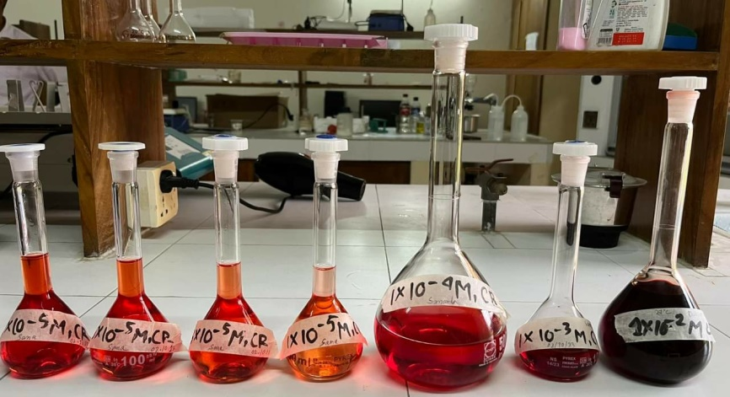

**Figure 3.1:** Several concentration of dye solution

**3.2.3. Study the Effect of the Amount of TiO2 Toward Rate of Degradation:**

Various amount such that 0.3g, 0.7g, 1g, 1.2g, 1.5g powered TiO2 were taken individually in 250ml beaker and 20ml distelled water was added and kept the solution for one night. Next day 20ml of dye with concentration 1×10-4 M and 60 mL H2O was added and then concentration of each solution turned into 2×10-5 M. In this time the PH of the solution was 7.40 and room temperature was 26.3oC. The source of radiation was comprised of a lamp emitting monochromatic radiation of 254 nm. The reactor was placed on a magnetically stirred plate. The total system was enclosed in a wooden box called lamp house. The instrument at which the experiments were carried out in the laboratory is given below-

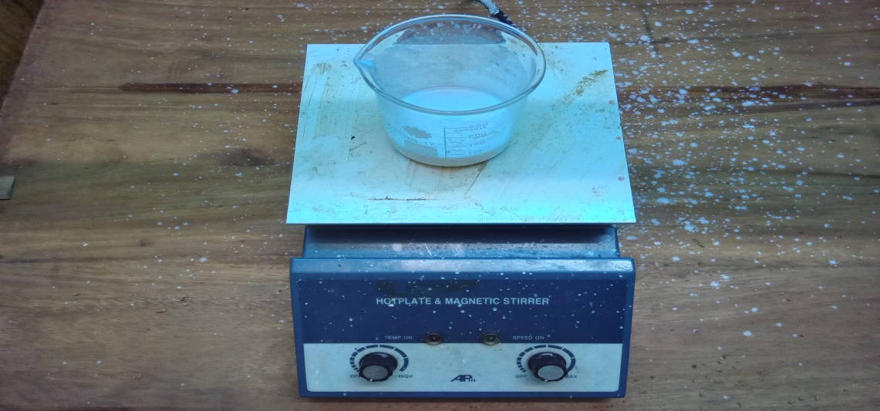

**Figure 3.2:** Photo degradation under UV light.

Then about 7ml of the solution (one by one) was collected in a test tube at 0 minute. The solution was collected in a test tube at different time intervals such as 5, 10, 20, 30, 40, 60 minutes respectively then all solution were centrifuged until get the clear solution and for it takes times about 35 minutes and their absorbance were measured.

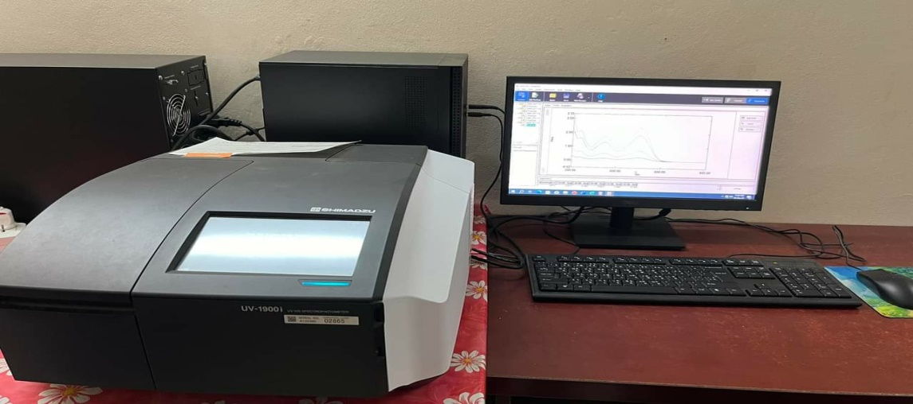

**Figure 3.3:** UV-Visible spectrophotometer.

**3.2.4 Study the Effect of Concentration Variation of Dye toward the Rate of Degradation:**

Various amount such as 10 ml, 40ml,50ml,70ml solution with concentration 1×10-4 M were mixed with fixed amount (1.2g) of TiO2 then make 100ml solution by adding water. Then carried out the experiment as like as done in the amount variation.

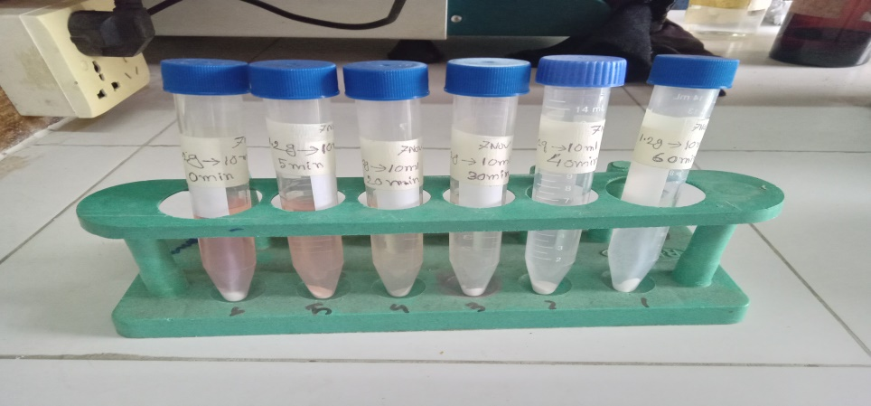

**Figure 3.4:** Sample collection in test tube.

**3.2.5 Study the Effect of Rate of Degradation in the Sunlight and the Absence of Light:**

1.2g TiO2 and 20ml dye with 1×10-4M was taken in beaker and prepared 100ml solution by adding water. Then the experiment was carried in sunlight and in darkness in the same manner.

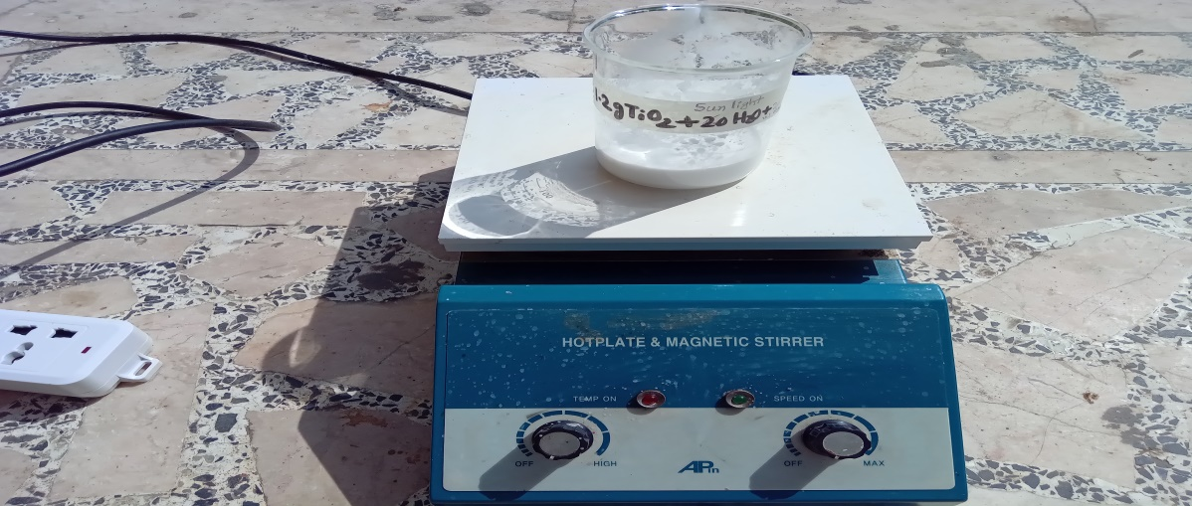

**Figure 3.5:** Photodegradation under sunlight

**CHAPTER 4**

**RESULTS**

**4.1 Typical UV-visible Spectra of Congo Red**

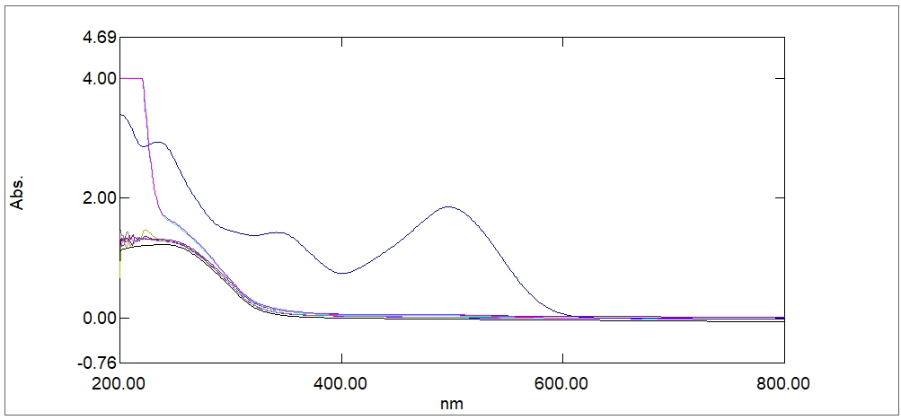

**Figure 4.1:** UV-Visible Spectrum of Congo red (decreasing concentration from top to bottom).

The efficiency of degradation Congo red dye can be calculated by using the decolorization formula.

***Decolorization (%) = ×100***

where *A* is referring to final absorbance of Congo red solution at the time interval and the *Ao* is the initial absorbance of the Congo red solution.

**4.2 Construction of Calibration Curve & Determination of Molar Absorption Coefficient (*Ԑmax*) of Congo Red**

Absorption maximum of Congo Red was determined spectrophotometrically from its absorption spectrum. The major peaks were observed at *λmax* = 498 nm. Thus, all the sample analysis was carried out at this *λmax*.

**Table 4.1: Measured absorbance of Congo Red at wavelength 498 nm.**

|  |  |
| --- | --- |
| **Concentration×105 (M)** | **Absorbance** |
| 1 | 0.242 |
| 3 | 0.734 |
| 5 | 1.203 |
| 8 | 1.832 |
| 10 | 2.368 |

According to Beer-Lambert law (A = εcl), a plot of A vs. C should give a straight line through origin. The slope of such a straight line gives the product of c & l. Since the path length is unity so slope gives molar extinction coefficient ε. The molar extinction coefficient (ε) obtained from the graph at 498 nm is 23520.

**Figure 4.2:** Calibration curve of Congo red at 498 nm.

**4.3 Effect of Catalyst Dose**

**Table 4.2: % of Degradation after 60 minutes with different amount of TiO2 under UV-light at 498 nm.**

|  |  |  |  |
| --- | --- | --- | --- |
| Amount of TiO2 (g) | Initial Absorbance | Final Absorbance | % of degradation |
| 0.3 | 0.833 | 0.249 | 70.10 |
| 0.7 | 0.879 | 0.291 | 66.89 |
| 1.0 | 0.580 | 0.210 | 63.79 |
| 1.2 | 0.544 | 0.135 | 75.18 |
| 1.5 | 0.619 | 0.191 | 69.14 |

**4.4 Effect of Dye Concentration**

**Table 4.3: Absorbance and percentage of degradation at different concentration variation with 1.2g of TiO2**

|  |  |  |  |
| --- | --- | --- | --- |
| **Concentration × 105M** | **Initial Absorbance** | **Final Absorbance** | **% of degradation** |
| 1 | 0.372 | 0.048 | 87.10 |
| 2 | 0.544 | 0.135 | 75.18 |
| 4 | 1.570 | 0.605 | 61.46 |
| 5 | 2.006 | 0.974 | 51.45 |
| 7 | 2.096 | 1.036 | 50.57 |

Concentration×105M

**4.5 Effect of Light on the % of Degradation**

**Table 4.4: % of degradation of CR at UV-light, Sun-light and in the absence of light at different time interval.**

|  |  |  |  |
| --- | --- | --- | --- |
| **Time (min)** |  | **% of degradation** |  |
|  | UV-light | Sun-light | Darkness |
| 5 | 17.46 | 35.85 | 0.45 |
| 10 | 27.38 | 47.89 | 0.45 |
| 20 | 47.05 | 64.14 | 1.35 |
| 30 | 54.96 | 73.38 | 1.80 |
| 40 | 62.38 | 78.71 | 1.00 |
| 60 | 75.18 | 84.03 | 0.02 |

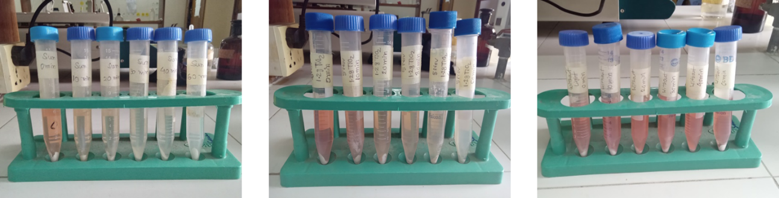

**Figure 4.3:** Images of the continuous decolorization (left to right → 10 to 60 minutes of reaction time) under sunlight, UV light and in dark respectively.

**CHAPTER 5**

**DISCUSSION**

**5.1 Effect of Catalyst Dose**

The amount of the photo catalyst affects the rate of photocatalytic degradation. It has been found that, as the concentration of catalyst increases the rate of degradation increases up to a maximum at 1.2 g/100 mL of TiO2. Under the UV-light irradiation, the maximum photodegradation (75%) was obtained for 1.2g of TiO2. Increase in the rate of degradation with increase in amount of catalyst is due to availability of more catalyst surface area for absorption of quanta and interaction of molecules in the reaction mixture with catalyst. The percent degradation of Congo Red decreases after attaining a maximum at 1.2 g/100 mL of TiO2. This is because when amount of TiO2 is high, the suspension becomes turbid. As a result, light cannot penetrate into the suspension and thus the rate of photodegradation decreases.

**Figure 5.1:** % of photodegradation with various amounts of TiO2 at 498 nm.

**5.2 Effect of Initial Concentration of Dye**

After optimizing the catalyst concentration of the matrix (catalyst dose 1.2g/100mL), the photocatalytic degradation of CR solution has been carried out by varying the initial concentration of the RRR from 1×10-5 to 7×10-5 M in order to assess the appropriate concentration required for maximum degradation. Figure 5.2 shows that percent degradation of CR decreases with increasing of dye concentration.

**Figure 5.2:** % of photodegradation at different concentration of Congo red with 1.2g of TiO2.

It is evident that degradation efficiency is inversely affected by the dye concentration. This can be explained, as the dye concentration is increased, the equilibrium adsorption of dye on the catalyst surface active sites increases; hence competitive adsorption of •OH on the same sites decreases, meaning a lower formation rate of. •OH radical, which is the principal oxidant necessary for a high degradation efficiency. On the other hand, considering the Beer-Lambert law, as the initial dye concentration increases, the path length of photons entering the solution decreases, resulting in lower photon absorption on catalyst particles and consequently a lower photodegradation rate.

**5.3 Effect of Light on the % of Degradation**

The percentage of degradation of Congo red in the presence of TiO2 under the artificial UV lamp is 75.18% after 60 minutes of irradiation time. When treated with the presence of a catalyst under sunlight, the dyes degrade about 84.03%. The extent of photodegradation under artificial UV/sunlight is found to be increased proportionally with time. However, treating under sunlight radiation will give more percentage in degradation. The sunlight can’t excite the TiO2 molecule. As a result, the separation of electron-hole pair from TiO2 molecule is not occurred. In the current research, the type of photochemical reaction is actually a photosensitization reaction where the dye molecule initially absorbs the light and become excited. Later, the energy is transformed to the TiO2 molecule which cause further photochemical reaction and degrade the dye. The amount of decolourization is found under the solar light irradiation rather than the UV-visible light. In absence of light, there is no excitation/hole-pair generation of the reactant molecules (dye or photocatalyst). That is why the amount of photodegradation is negligible in comparison to sunlight and UV-light.

**Figure 5.3:** % of degradation of CR under sunlight, UV light and in absence of light with 1.2g of TiO2 respectively.

A possible mechanism for the photodegradation under solar light irradiation is –

dyeads+ *hν*→ *dyeads

*dyeads + TiO2→ TiO2 (e-) + dyeads +

Alternatively,

dye + *hν*→ *dye

*dye + TiO2→ TiO2 (e-) + dyeads +

Then the following steps may occur.

TiO2 (e-) + O2 → TiO2 + O2-

O2- + H+ → HO•

HO• + H+ + TiO2 (e-) → TiO2 + H2O2

H2O2+ TiO2 (e-) → OH- + OH-

Dyeads + + (OH-, O2- , and/or O2) → degraded products.

Dyeads* indicates dye adsorbed on the surface of TiO2. TiO2 (e-) indicates an electron trapped in the TiO2 matrix.

**5.4 IR Spectra of Congo Red**

**Figure 5.4:** IR analysis of pure Congo red and degraded Congo red**.**

The N-H stretches of amines are in the region 3300-3000 cm-1. These bands are weaker and sharper than that of the alcohol O-H stretches which appear in the same region. Similiarly, the N-H bending for primary and secondary amine is in the region between 1640-1560 cm-1 and 1500 cm-1. In our experiment, we observe a bond peak in 3400 cm-1 which is for hydrogen bonding between NH2 group and OH group [32]. Similarly, some weak peak found in the range 1507-1560 cm-1 due to carbon-carbon stretching vibrations in the aromatic ring. In addition, a sharp peak is found in the region 1600 cm-1 due to bending vibration of primary amine. But there is a difference between pure and degraded Congo red which is intensity. For degraded Congo red, the intensity become lower than Congo red. Finally, we expect that after the complete degradation of Congo red the IR spectra will be similar as solvent pure water.

**CHAPTER 6**

**CONCLUSION**

Semiconductor oxide (i.e. ZnO, TiO2, CdS, etc.) mediated photodegradation is one of the promising techniques for mortifying the organic contaminants including dyes and other toxic organic compounds. TiO2 is one of the appropriate semiconductors for this purpose. TiO2 mediated photo degradation using UV or solar light can proficiently be used for the degradation of non-biodegradable toxic compound used in industries and municipal waste water managements as well. The experiment proved that the uses of titanium dioxide as a catalyst in photo degradation of Congo red dye enhanced the degradation process. The treatment of dye under direct sunlight and artificial UV light irradiation showed photocatalytic activities where the sunlight showed better efficiency. Treatment of Congo red dye with artificial UV light show 75.18% degradation after 60 minutes reaction time whereas it 84.03% for sunlight.

The percentage of degradation was found to affect by the quantity of catalyst. The percentage of degradation initially increases with an increase in the concentration of TiO2 suspension. After reaching a maximum of 1.2g/100 mL, the percentage of degradation decreased with a further increase in the concentration of TiO2 suspension, might be due to the less amount of light penetration to the solution. Photocatalytic efficiency is found to be inversely proportional with the initial concentration of dye. The removal efficiency of industrial waste water depended on the intensity of light. The percentage of degradation for the current research is not satisfactory, might be related to the light intensity. The experiments were done in the month of October and November, 2023, in which the light intensity was not quite enough to degrade the molecules at a higher rate. It was expected that in a sunny day, when the intensity of light would be higher, the degradation efficiency would be noticeable. In that case, TiO2 will be a better photocatalyst to depollute industrial waste water.

**CHAPTER 7**

**REFERENCES**

|  |  |
| --- | --- |
|  | N. H. Harun, M. N. A. Rahman, W. F. W. Kamarudin, Z. Irwan, A. Muhammud, N. E. F. M. Akhir and M. R. Yaafar |
|  | N. H. Harun et al. J Fundam Appl Sci. 2018, 10(1S), 832-846. |
|  | A.K.DE, Environmental Chemistry, New Age International (P) Limited, 7th edition, pp 189. |
|  | A.K.DE, Environmental Chemistry, New Age International (P) Limited, 7th edition, pp 197. |
|  | Riga A, Soutsas K, Ntampegliotis K, Karayannis V, Papapolymerou G. Effect of system parameters and of inorganic salts on the decolorization and degradation of Procion H-exl dyes: Comparison of H2O2/UV, Fenton, UV/Fenton, TiO2/UV and TiO2/UV/H2O2 processes. Desalination, 2007, 211(1-3):72-86. |
|  | Mittal A, Thakur V, Gajbe V. Adsorptive removal of toxic azo dye Amido Black 10B by hen feather. Environmental Science and Pollution Research, 2013, 20(1):260-269. |
|  | Barka N, Qourzal S, Assabbane A, Nounah A, Ait-Ichou Y. Photocatalytic degradation of an azo reactive dye, Reactive Yellow 84, in water using an industrial titanium dioxide coated media. Arabian Journal of Chemistry, 2010, 3(4):279-283. |
|  | Peternel I T, Koprivanac N, Božid A M, Kušid H M. Comparative study of UV/TiO2, UV/ZnO and photo-Fenton processes for the organic reactive dye degradation in aqueous solution. Journal of Hazardous Materials, 2007, 148(1):477-484. |
|  | Arslan I, Balcioǧlu I A, Bahnemann D W. Advanced chemical oxidation of reactive dyes in simulated dyehouse effluents by ferrioxalate-Fenton/UV-A and TiO2/UV-A processes. Dyes and Pigments, 2000, 47(3):207-218. |
|  | Anbalagan A. Combination of biological and photochemical treatment for degradation of azo dyes. Master thesis, Sweden: Uppsala University, 2012. |
|  | Pirkarami A, Olya M E. Removal of dye from industrial wastewater with an emphasis on improving economic efficiency and degradation mechanism. Journal of Saudi Chemical Society, 2014, 21(Supplement 1):1319-6103. |
|  | Choy, K.K.H., McKay, G. and Porter, J.F., 1999, Resources, Conservation and Recycling, 27, 57- 71. |
|  | A.K.DE, Environmental Chemistry, New Age International (P) Limited, 7th edition, pp 211- 227. |
|  | A.K.DE, Environmental Chemistry, New Age International (P) Limited, 7th edition, pp 197202. |
|  | Lee, J. M., Kim, M. S., Hwang, B., Bae, W. and Kim, B. W., 2003, Dyes and Pigments, 56, 59– 67. |
|  | Neamtu, M., Siminiceanu, I., Yediler, A. and Kettrup, A., 2002, Dyes. |
|  | Naseem, K.; Farooqi, Z.H.; Begum, R.; Irfan, A. Removal of Congo red dye from aqueous medium by its catalytic reduction using sodium borohydride in the presence of various inorganic nano-catalysts: A review. J. Clean. Prod. 2018, 187, 296–307 |
|  | IARC Working Group on the Evaluation of Carcinogenic Risks to Humans. Chemical Agents and Related Occupations. Lyon (FR): International Agency for Research on Cancer; 2012. (IARC Monographs on the Evaluation of Carcinogenic Risks to Humans, No. 100F. Dyes metabolized to benzidine. |
|  | D’Souza, E.; Fulke, A.B.; Mulani, N.; Ram, A.; Asodekar, M.; Narkhede, N.; Gajbhiye, S.N. Decolorization of Congo red mediated by marine Alcaligenes species isolated from Indian West coast sediments. Environ. Earth Sci. 2017, 76, 721. |
|  | I. Arslan and I. A. Balcio˘glu, Dyes and Pigments, 1999, 43, 95–108. |
|  | K. Kunitou, S. Maeda, S. Hongyou and K. Mishima, Can. J. Chem. Eng., 2002, 80, 208–213. |
|  | K. S. Tilak, and R. Swarnakumari, J. Env. Biol., 2009, 30(6), 1031-1033. |
|  | L. A. Blady., A. T. Ricardo., P. Gustavo., Journal of Hazardous Materials, 2011, 191, 196. |
|  | M. N. Kayes, M. J. Miah, M. Obaidullah, M. A. Hossain and M. M. Hossain, 2016, Journal of Advances in Chemistry, 12 (6), 4127-4133. |
|  | Papageorgiou S K, Katsaros F K, Favvas E P, Romanos G E, Athanasekou C P, Beltsios K G, Tzialla O I, Falaras P. Alginate fibers as photocatalyst immobilizing agents applied in hybrid photocatalytic/ultrafiltration water treatment processes. Water Research, 2012, 46(6):1858- 1872. |
|  | Anbalagan A. Combination of biological and photochemical treatment for degradation of azo dyes. Master thesis, Sweden: Uppsala University, 2012. |
|  | Pirkarami A, Olya M E. Removal of dye from industrial wastewater with an emphasis on improving economic efficiency and degradation mechanism. Journal of Saudi Chemical Society, 2014, 21(Supplement 1):1319-6103. |
|  | Abo-Farha S A. Photocatalytic degradation of monoazo and diazo dyes in wastewater on nanometer-sized TiO2. Journal of American Science, 2010, 6(11):130-142. |
|  | Barka N, Qourzal S, Assabbane A, Nounah A, Ait-Ichou Y. Photocatalytic degradation of an azo reactive dye, Reactive Yellow 84, in water using an industrial titanium dioxide coated media. Arabian Journal of Chemistry, 2010, 3(4):279-283. |
|  | Kušid H, Božid AL, Koprivanac N. Fenton type processes for minimization of organic content in coloured wastewaters: Part I: Processes optimization. Dyes and Pigments, 2007, 74(2):380-387. |
| [31] | Bizani E, Fytianos K, Poulios I, Tsiridis V. Photocatalytic decolorization and degradation of dye solutions and wastewaters in the presence of titanium dioxide. Journal of Hazardous Materials, 2006, 136(1):85-94. |
| [32] | Lafi, R., Montasser, I., &amp; Hafiane, A. (2019). Adsorption of congo red dye from aqueous solutions by prepared activated carbon with oxygen-containing functional groups and its regeneration. Adsorption Science &amp; Technology, 37(1-2), 160-181. |
|  |  |
|  |  |